**SUSPICIOUS ACTIVITY DETECTION FROM CCTV FOOTAGE**

A Project Report Submitted

in

Partial fulfilment of the Requirements

For the Award of the Degree of

Bachelor of Technology

In

**COMPUTER SCIENCE AND ENGINEERING**

**Submitted**

**By**

N.Sathish Kumar(19541A0578) V.Naga Pavan Durga(20545A0506)

B.Sai Chandana(19541A0506) M.Venkata Vamsi(19541A0572)

M.Lakshmi Susmitha(19541A0522)

**Under the Guidance of**

**Mr.B.Raju**

Assistant Professor of CSE



**2019-2023**

**DEPARTMENT OF COMPUTER SCIENCE AND ENGINEERING**

**SRI SARATHI INSTITUTE OF ENGINEERING & TECHNOLOGY**

**(An ISO 9001:2008 certified Institution)**

**(Approved by AICTE, Affiliated to JNTUK)**

**NUZVID – 521 201, Eluru District, A.P.**

**April,2023.**

**SRI SARATHI INSTITUTE OF ENGINEERING & TECHNOLOGY**

**(Approved by AICTE Affiliated to JNTUK, ISO 9001:2008 Certified)**

**DEPARTMENT OF COMPUTER SCIENCE AND ENGINEERING**



**CERTIFICATE**

This is to certify the Project Report entitled”Suspicious Activity Detection From CCTV Footage” Submitted by N.Sathish Kumar(19541A0578),V.Naga Pavan Durga(20545A0506), B.Sai Chandana (19541A0506),M.Venkata Vamsi(19541A0572),M.Lakshmi Susmitha(19541A0522) in partial fulfilment of requirements for the award of the degree of Bachelor of Technology in Computer Science and Engineering to the Jawaharlal Nehru Technological University, Kakinada is a record of bonafide work carried out by him/her under our guidance and supervision .

The results embodied in this project report have not been submitted to any other university for the award on any degree or diploma by any student of this college or any other university.

|  |  |
| --- | --- |
| **Signature of internal Guide** | **Signature of the HOD** |
| Mr.B.Raju | Dr. K.Nageswara Rao.Ph.D |
| Assistant professor of CSE | Head of the Dept |

**Signature of External Examiner**

**DECLARATION**

We hereby declare that this Project Report entitled “**Suspicious Activity Detection From CCTV Footage** ” to **Jawaharlal Nehru Technological University, Kakinada**, is a genuine work carried out by us, for the partial fulfilment of the degree of **Bachelor of Technology** in **Computer Science and Engineering** during the academic year 2019-2023 under the supervision of our guide **Mr.B.RAJU., Assistant professor of CSE,** in **SRI SARATHI INSTITUTE OF ENGINEERING AND TECHNOLOGY, NUZVID.**

**N.Sathish Kumar**(19541A0578).

**V.Naga Pavan Durga**(20545A0506).

**B.Sai Chandana**(19541A0506).

**M.Venkata Vamsi**(19541A0572).

**M.Lakshmi Susmitha**(19541A0522).

### ACKNOWLEDGEMENT

We thank our honourable chairman **Sri. S.V. SUDHEER** garu, for his moral support and the excellent facilities provided. We are grateful to **Sri. S. SRIDHAR** garu, Principal, **Sri Sarathi Institute of Engineering & Technology, Nuzvid**, for his support throughout the project for given the permission to undergo the project work.

We would also like to thank **Sri Dr.K .Nageswara Rao** Ph.D. garu **Head of the Department, Department of Computer Science Engineering and Technology** for having given us the opportunity to complete the project successfully.

We sincerely thanks to **Mr.B.RAJU** garu, **Assistant Professor of Computer Science and Engineering, Sri Sarathi Institute of Engineering and Technology,** Nuzvid for his valuable guidance and support.

I thank for timely suggestions and constant encouragement that boosted up our moral and let to the accomplishment of this project.

Firstly, we indebted to my parents, friends and relatives for the physical, psychological and moral extended by them at all time.

**Project Associates-**

|  |  |
| --- | --- |
| **Names of the students** | |
| **N.SATHISH KUMAR**  **B.SAI CHANDANA**  **V.NAGA PAVAN DURGA**  **M.VENKATA VAMSI**  **M.LAKSHMI SUSMITHA** | **19541A0578**  **19541A0506**  **20545A0506**  **19541A0572**  **19541A0522** |
|  |  |

**ABSTRACT**

In today’s insecure world the video surveillance plays an important role for the security of the indoor as well as outdoor places. The components of video surveillance system such as behavior recognition, understanding and classifying the activity as normal or suspicious can be used for real time applications. In this paper the hierarchical approach is used to detect the different suspicious activities such as loitering, fainting, unauthorized entry etc. This approach is based on the motion features between the different objects. First of all the different suspicious activities are defined using semantic approach. Then the object detection is done using background subtraction. The detected objects are then classified as living (human) or non living (bag). These objects are required to be tracked which is done using correlation technique. Finally using the motion features & temporal information the events are classified as normal or suspicious. As the semantic based approach is used computational complexity is less and the efficiency of the approach is more.

**S.NO CONTENTS PG.NO**

1. **INTRODUCTION**  1
   1. What is Machine Learning? 2
   2. What is suspicious Activity? 3
   3. Purpose 4

**2.** **LITERATURE SURVEY** 5-7

**3. SYSTEM ANALYSIS**  8

3.1 Existing system 9

3.2 Disadvantage of existing system 10

3.3 proposed system 10

3.4 Advantage of proposed system 10

3.5 System architecture 11

3.6 Modules 12

3.6.1 Module 1 12

3.6.2 Module 2 12

3.6.3 Module 3 12

3.6.4 Module 4 12

3.6.5 Module 5 12

3.7 System requirements 13

3.8 Feasibility study 14

3.9 Economic feasibility 14

3.10 Operational feasibility 14

3.11 Technical feasibility 14

**4. SYSTEM DESIGN**  15

4.1 Introduction 16

4.2 Input design 16

4.3 Output design 17

4.4 Uml diagrams 18-19

4.4.1 Class diagram 20

4.4.2 Use Case diagram 21

4.4.3 Sequence diagram 22

4.4.4 Activity diagram 23

**5. SYSYTEM IMPLEMENTATION** 24

5.1 Coding 25-29

5.2 About Python 29-53

5.3 Screen shots 54-60

**6. SYSTEM TESTING** 61-64

6.1 Unit testing

6.2 Integration testing

6.3 Functional testing

**7. CONCLUSION&FUTURE ENHANCEMENT** 65

7.1 Conclusion 66

7.2 Future enhancement 66

**8. REFERENCES** 67-68

**9. BIBLIOGRAPHY** 69

**LIST OF FIGURES**

|  |  |  |  |
| --- | --- | --- | --- |
| **S.NO** | **FIG.NO** | **FIGURE NAME** | **PAGE.NO** |
| **1** | **3.5** | **System architecture** | 11 |
| **2** | **4.4.1** | **Class diagram** | 20 |
| **3** | **4.4.3** | **Sequence diagram** | 22 |
| **4** | **4.4.4** | **Activity diagram** | 23 |
| **5** | **4.4.2** | **Use case diagram** | 21 |

**INTRODUCTION**

**1. INTRODUCTION**

In recent years the violence or the crime rate is increasing all over the world. In order to minimize or to control the situation various aids are used. The video surveillance is the `best option which can be used in private as well as for public places. The video surveillance is said to be effective when it detect any abnormal /suspicious activities efficiently. Most of the current surveillance systems are human operated. So they require continuous human attention to detect any abnormal activity. As the human is involved the efficiency of the system decreases with time due to fatigueness factor of human. This problem can be solved by the automation of the video surveillance. The function of the automated system is to give indication in the form of alarm or any other form when the predefined abnormal activity is happen. Dr. C.G.Patil Dept. of E & TC SAE, Pune Pune, India [Cgpatil.sae@sinhgad.edu](mailto:Cgpatil.sae@sinhgad.edu) In this paper a semantic based approach is used to define & detect the suspicious activities. The framework of the system consists of defining suspicious activity, background subtraction, objects detection, tracking & classification of activities. The suspicious activities are defined using Semantic approach which applies the human understanding of the activity. The motion features between the two/different objects are extracted to detect the behavior. The disadvantages of the machine learning such as unavailability of standard datasets, generalizing ability of the classifier can be overcome using the semantic based approach. The content of the paper are as follows In section two the work done by different researchers in this field is studied. Section three describes the system flow and the working of the system. In section four the results which are obtained after experiment are shown. The last section is the conclusion which is drawn from the results obtained.

**1.1 WHAT IS MACHINE LEARNING ?**

Machine learning is a branch of [artificial intelligence (AI)](https://www.ibm.com/in-en/cloud/learn/what-is-artificial-intelligence) and computer science which focuses on the use of data and algorithms to imitate the way that humans learn, gradually improving its accuracy.

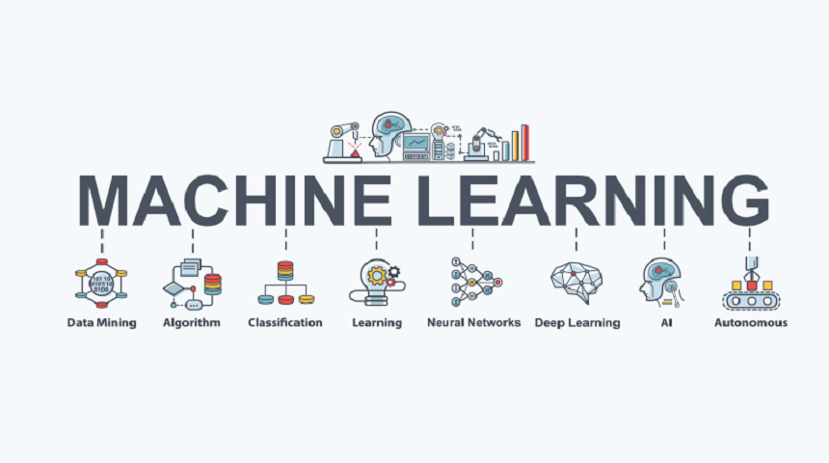

# Fig : Machine Learning

Machine learning is an important component of the growing field of data science. Through the use of statistical methods, algorithms are trained to make classifications or predictions, uncovering key insights within data mining projects. These insights subsequently drive decision making within applications and businesses, ideally impacting key growth metrics. As big data continues to expand and grow, the market demand for data scientists will increase, requiring them to assist in the identification of the most relevant business questions and subsequently the data to answer them.

**1.2WHAT IS SUSPICIOUS ACTIVITY?**

In recent years the violence or the crime rate is increasing all over the world. In order to minimize or to control the situation various aids are used. The video surveillance is the best option which can be used in private as well as for public places. The video surveillance is said to be effective when it detect any abnormal /suspicious activities efficiently. Most of the current surveillance systems are human operated. So they require continuous human attention to detect any abnormal activity. As the human is involved the efficiency of the system decreases with time due to fatigueness factor of human. This problem can be solved by the automation of the video surveillance. The function of the automated system is to give indication in the form of alarm or any other form when the predefined abnormal activity is happen. Dr. C.G.Patil Dept. of E & TC SAE, Pune Pune, India Cgpatil.sae@sinhgad.edu In this paper a semantic based approach is used to define & detect the suspicious activities. The framework of the system consists of defining suspicious activity, background subtraction, objects detection, tracking & classification of activities. The suspicious activities are defined using Semantic approach which applies the human understanding of the activity. The motion features between the two/different objects are extracted to detect the behavior. The disadvantages of the machine learning such as unavailability of standard datasets, generalizing ability of the classifier can be overcome using the semantic based approach. The content of the paper are as followsIn section two the work done by different researchers in this field is studied. Section three describes the system flow and the working of the system. In section four the results which are obtained after experiment are shown. The last section is the conclusion which is drawn from the results obtained.

**1.3PURPOSE:**

#### The main objective of video surveillance is to acquire & process the data so that any suspicious movement can be detected. A lot of research has been done addressing the detection of anomalies in the video data. The problem of abandoned bag detection is handled by the most of the researchers. Bitch et. al. 2011 [4], Tian et. al. 2010[5] they handled the abandoned bag detection problem as the static object detection with the application of the object tracking. While Evangelio & Sikora 2011 [3], Porikli et. al. 2008 [6] they did the static object detection without the use of tracking. In [2] Elhamod & Levine proposed a technique based on semantic approach to detect suspicious activity in public places. They use the background subtraction to identify the foreground object. This object is tracked using the foreground silhouettes. Then the activities are classified as normal or predefined suspicious activity. In [7] James David Hogg et al described the video surveillance framework to detect abandoned object in scene with multiple interacting objects. They use the standard datasets. The object (bag) detection is done by the dual background approach using Gaussian Mixture Model(GMM). The multi hypothesis tracker which is modified for tracking of extended objects is used. Then the situation analysis is done based on relationship between bag and people. Finally the threat assessment is done using logic based approach.

**LITERATURE SURVEY**

**2.LITERATURE SURVEY**

**TITLE:** Suspicious Movement Detection and Tracking based on Color Histogram.

**AUTHORS:** Sandesh Patil and Kiran Talele

## **ABSTRCT:**

In automated video surveillance applications, detection of suspicious human behaviour is of great practical importance. However due to random nature of human movements, reliable classification of suspicious human movements can be very difficult. Definin0g an approach to the problem of automatically tracking people and detecting unusual or suspicious movements in Closed Circuit TV (CCTV) videos is our primary aim. We are proposing a system that works for surveillance systems installed in indoor environments like entrances/exits of buildings, corridors, etc. Our work presents a framework that processes video data obtained from a CCTV camera fixed at a particular location. First, we obtain the foreground objects by using background subtraction. These foreground objects are then classified into people and inanimate objects (luggage). These objects are tracked using a real- time blob matching technique. Using temporal and spatial properties of these blobs, activitiesare classified using semantics-based approach.

**TITLE:** Static object detection based on a dual background model and a finite-state

machine.

**AUTHORS:** Evangelio, R., Sikora, T.

## **ABSTRACT:**

During the last few years, abandoned object detection has emerged as a hot topic in the video- Surveillance community. As a consequence, a myriad of systems has been proposed for automatic monitoring of public and private places, while addressing several challenges affecting detection performance. Due to the complexity of these systems, researchers often address independently the different analysis stages such as foreground segmentation, stationary object detection, and abandonment validation. Despite the improvements achieved for each stage, the advances are rarely applied to the full pipeline, and therefore, the impact of each stage of impovement on the overall system performance has not been studied. In this paper, we formalize the framework employed by systems for abandoned object detection and provide an extensive review of state-of-the-art approaches for each stage. We also build a multi- configuration system allowing one to select a range of alternatives for each stage with the objective of determining the combination achieving the best performance. This multi- configuration is made available online to the research community.

**SYSTEM ANALYSIS**

**3.1 EXISTING SYSTEM:**

The video surveillance is said to be effective when it detect any abnormal /suspicious activities efficiently. Most of the current surveillance systems are human operated. So they require continuous human attention to detect any abnormal activity. As the human is involved the efficiency of the system decreases with time due to fatigueness factor of human. This problem can be solved by the automation of the video surveillance. The function of the automated system is to give indication in the form of alarm or any other form when the predefined abnormal activity is happen.

The main objective of video surveillance is to acquire & process the data so that any suspicious movement can be detected. A lot of research has been done addressing the detection of anomalies in the video data. The problem of abandoned bag detection is handled by the most of the researchers. Bitch et. al, Tian et. al. they handled the abandoned bag detection problem as the static object detection with the application of the object tracking.

While Evangelio & Sikora, Porikli et. al. they did the static object detection without the use of tracking. In Elhamod & Levine proposed a technique based on semantic approach to detect suspicious activity in public places. They use the background subtraction to identify the foreground object. This object is tracked using the foreground silhouettes. Then the activities are classified as normal or predefined suspicious activity. In James David Hogg et al described the video surveillance framework to detect abandoned object in scene with multiple interacting objects. They use the standard datasets. The object (bag) detection is done by the dual background approach using Gaussian Mixture Model(GMM)

The multi hypothesis tracker which is modified for tracking of extended objects is used. Then the situation analysis is done based on relationship between bag and people. Finally the threat assessment is done using logic based approach. In Fuentes & Velastin present an algorithm based on trajectories to detect an event in video surveillance. Any event can be described in terms of position, trajectory, and split/ merge event. Then the matching matrices are used for tracking purpose. Kim et al deal with detecting & tracking multiple moving objects through a single camera.

**3.2 Disadvantages of Existing System:**

* + 1. Sometimes it will not detect accurate visuals .
    2. It will detect the problem not at the same time ,when the suspicious activity is going on without alerting the problem .

**3.3PROPOSED SYSTEM**

In this paper a semantic based approach is used to define & detect the suspicious activities. The framework of the system consists of defining suspicious activity, background subtraction, objects detection, tracking & classification of activities. The suspicious activities are defined using Semantic approach which applies the human understanding of the activity. The motion features between the two/different objects are extracted to detect the behaviour.

**3.4 Advantages of Proposed System:**

1. semantic based approach is used to define & detect the suspicious activities.
2. The motion features between the two/different objects are extracted to detect the behaviour**.**

# **3.5 SYSTEM ARCHITECTURE**

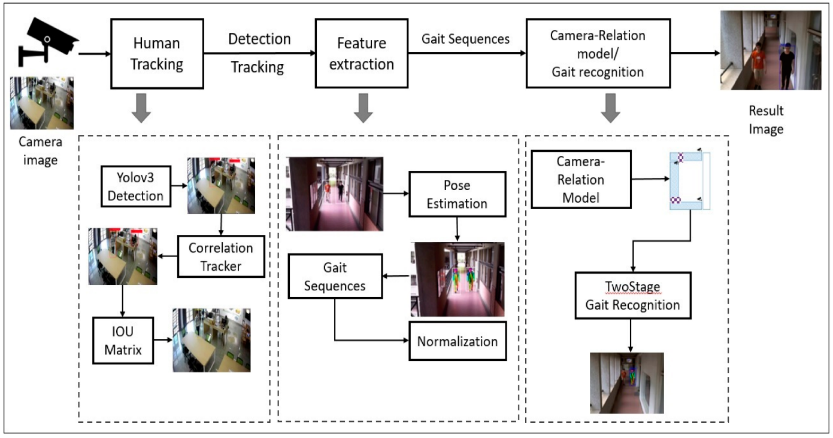

**Fig 3.5: Architecture Of Suspicious Activity Detection From CCTV Footage**

**3.6 MODULES**

**3.6.1 Input data:**

The input for the system is video stream. As the system is to be implemented to detect the suspicious activity its input is to be taken from the CCTV. But for the project/ demo we use the standard datasets. These input images are not in proper form so the different image preprocessing techniques are used to enhance the quality of the image.

**3.6.2 Background image acquisition:**

The illumination effect can be corrected by the background image. A reference image/ standard background is taken as reference for the further image processing. The background image is dynamically updated so that any new object entered in the scene can be captured.

**3.6.3 Image Processing:**

The different image preprocessing techniques are used to improve the image so that the unwanted distortions are get suppressed or some required features enhanced. The changing light conditions, movement of reference background cause some noise introduced in the image. We use the thresholding technique to remove the noise.

**3.6.4 Object Detection:**

The foreground image is obtained by the subtraction of the input image from the background image. From this foreground image the required object is detected.

**3.6.5 Object Tracking:**

In the scene or if any object left the scene i.e. the person walk off the scene. The detected object (human being or bag) is tracked using correlation tracking algorithm.

**3.7 SYSTEM REQUIREMENTS**

**HARDWARE REQUIREMENTS:**

* + - **System :** Intel i3 2.2Ghz
    - **Hard Dis :** 320 GB.
    - **Ram :** 4 GB.

**SOFTWARE REQUIREMENTS:**

* **Operating system :** Windows 7 Ultimate.
* **Coding Language :** Python.
* **Front-End :** Python.
* **IDE :** Pycharm 2020 Community.

**3.8 FEASIBILITY STUDY:** The feasibility of the project is analyzed in this phase and business proposal is put forth with a very general plan for the project and some cost estimates. During system analysis the feasibility study ofthe proposed system is to be carried out. This isto ensure that the proposed system is not a burden to the company. For feasibility analysis, some understanding of the major requirements for the system is essential.

**Three key considerations involved in the feasibility analysis are,**

* **ECONOMICAL FEASIBILITY**
* **OPERATIONAL FEASIBILITY**
* **TECHNICAL FEASIBILITY**

**3.9 ECONOMICAL FEASIBILITY:**

This study is carried out to check the economic impact that the system will have on the organization. The amount of fund that the company can pour into the research and development of the system is limited. The expenditures must be justified. Thus the developed system as well within the budget and this was achieved because most of the technologies used are freely available. Only the customized products had to be purchased.

**3.10 OPREATIONAL FEASIBILITY:**

Operational feasibility is the measure of how well a proposed system solves the problems, and takes advantage of the opportunities identified during scope definition and how it satisfies the requirements identified in the requirements analysis phase of system development.

The operational feasibility assessment focuses on the degree to which the proposed development project fits in with the existing business environment and objectives with regard to development schedule, delivery date, corporate culture and existing business processes.

**3.11 TECHNICAL FEASIBILITY:**

This study is carried out to check the technical feasibility, that is, the technical requirements of the system. Any system developed must not have a high demand on the available technical resources. This will lead to high demands on the available technical resources. This will lead to high demands being placed on the client.

**SYSTEM DESIGN**

**4.SYSTEM DESIGN**

**4.1 INTRODUCTION:** Systems design is the process of defining elements of a system like modules, architecture, components and their interfaces and data for a system based on the specified requirements.

**INPUT AND OUTPUT DESIGN**

**4.2 INPUT DESIGN:**

The input design is the link between the information system and the user. It comprises the developing specification and procedures for data preparation and those steps are necessary to put transaction data in to a usable form for processing can be achieved by inspecting the computer to read data from a written or printed document or it can occur by having people keying the data directly into the system. The design of input focuses on controlling the amount of input required, controlling the errors, avoiding delay, avoiding extra steps and keeping the process simple. The input is designed in such a way so that it provides security and ease of use with retaining the privacy. Input Design considered the following things:

* + - What data should be given as input?
    - How the data should be arranged or coded?
    - The dialog to guide the operating personnel in providing input.
    - Methods for preparing input validations and steps to follow when error occur.

**OBJECTIVES:**

1. Input Design is the process of converting a user-oriented description of the input into a computer-based system. This design is important to avoid errors in the data input process and show the correct direction to the management for getting correct information from the computerized system.
2. It is achieved by creating user-friendly screens for the data entry to handle large volume of data. The goal of designing input is to make data entry easier and to be free from errors. The data entry screen is designed in such a way that all the data manipulates can be performed. It also provides record viewing facilities.

3.When the data is entered it will check for its validity. Data can be entered with the help of screens. Appropriate messages are provided as when needed so that the user will not be in maize of instant.

**4.3 OUTPUT DESIGN:**

A quality output is one, which meets the requirements of the end user and presents the information clearly. In any system results of processing are communicated to the users and to other system through outputs. In output design it is determined how the information is to be displaced for immediate need and also the hard copy output. It is the most important and direct source information to the user. Efficient and intelligent output design improves the system’s relationship to help user decision-making.

1. Designing computer output should proceed in an organized, well thought out manner; the right output must be developed while ensuring that each output element is designed so that people will find the system can use easily and effectively. When analysis design computer output, they should Identify the specific output that is needed to meet the requirements.

2.Select methods for presenting information.

3.Create document, report, or other formats that contain information produced by the system.

The output form of an information system should accomplish one or more of the following objectives.

* Convey information about past activities, current status
* projections of the Future.

**4.4 UML DIAGRAMS:**

UML stands for Unified Modeling Language. UML is a standardized general-purpose modeling language in the field of object-oriented software engineering. The standard is managed, and was created by, the Object Management Group.

The goal is for UML to become a common language for creating models of object oriented computer software. In its current form UML is comprised of two major components: a Meta- model and a notation. In the future, some form of method or process may also be added to; or associated with, UML.

T’he Unified Modeling Language is a standard language for specifying, Visualization, Constructing and documenting the artifacts of software system, as well as for business modeling and other non-software systems.

The UML represents a collection of best engineering practices that have proven successful in the modeling of large and complex systems.

The UML is a very important part of developing objects oriented software and the software development process. The UML uses mostly graphical notations to express the design of software projects.

**GOALS:**

The Primary goals in the design of the UML are as follows:

1. Provide users a ready-to-use, expressive visual modeling Language so that they can develop and exchange meaningful models.
2. Provide extendibility and specialization mechanisms to extend the core concepts.
3. Be independent of particular programming languages and development process.
4. Provide a formal basis for understanding the modeling language.
5. Encourage the growth of OO tools market.
6. Support higher level development concepts such as collaborations, frameworks, patterns and components.
7. Integrate best practices.

**4.4.1 CLASS DIAGRAM:**

In software engineering, a class diagram in the Unified Modeling Language (UML) is a type of static structure diagram that describes the structure of a system by showing the system's classes, their attributes, operations (or methods), and the relationships among the classes. It explains which class contains information.

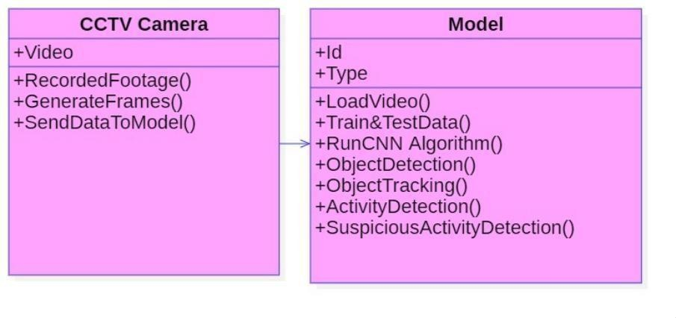

**4.4.2 USE CASE DIAGRAM:**

A use case diagram in the Unified Modeling Language (UML) is a type of behavioral diagram defined by and created from a Use-case analysis. Its purpose is to present a graphical overview of the functionality provided by a system in terms of actors, their goals (represented as use cases), and any dependencies between those use cases. The main purpose of a use case diagram is to show what system functions are performed for which actor. Roles of the actors in the system can be depicted.

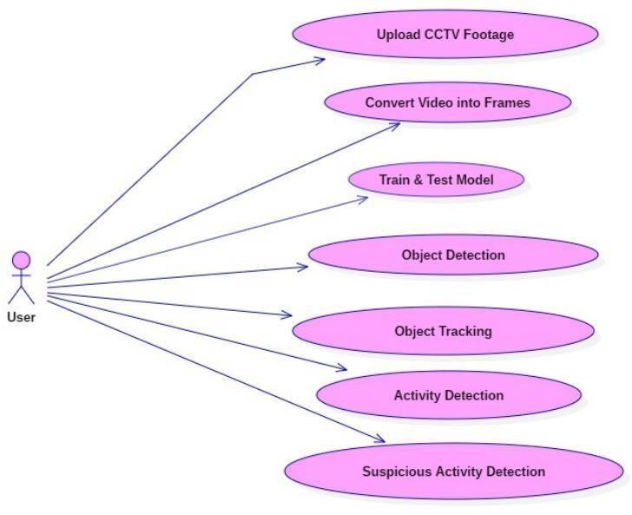

**4.4.3 SEQUENCE DIAGRAM:**

A sequence diagram in Unified Modeling Language (UML) is a kind of interaction diagram that shows how processes operate with one another and in what order. It is a construct of a Message Sequence Chart. Sequence diagrams are sometimes called event diagrams, event scenarios, and timing diagrams.

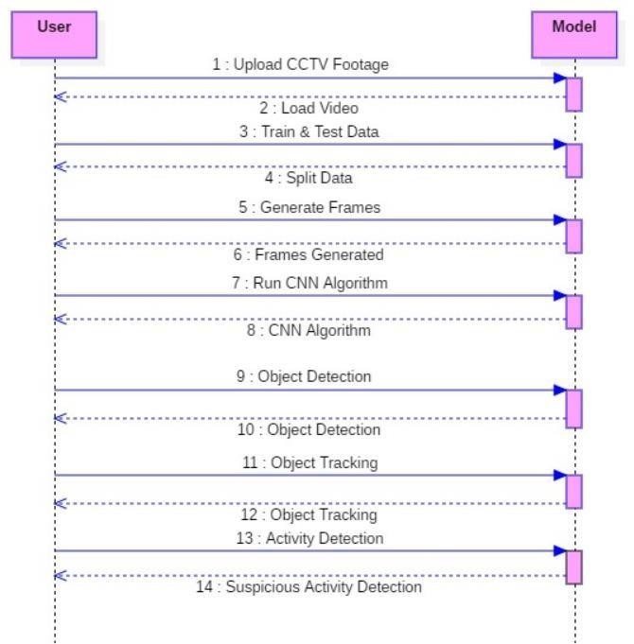

* + 1. **ACTIVITY DIAGRAM:**

Activity diagrams are graphical representations of workflows of stepwise activities and actions with support for choice, iteration and concurrency. In the Unified Modeling Language, activity diagrams can be used to describe the business and operational step-by-step workflows of components in a system. An activity diagram shows the overall flow of control.

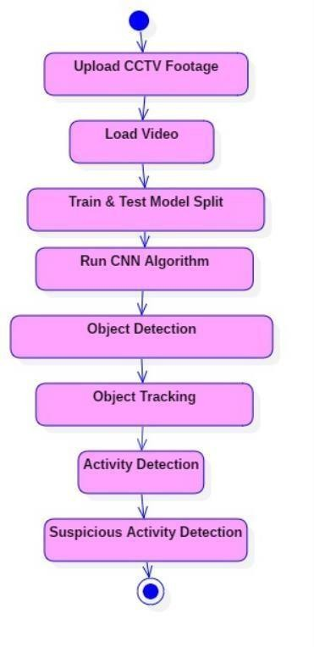

**SYSTEM IMPLEMENTATIONS**

**5. SYSTEM IMPLEMENTATIONS**

**5.1 CODING:**

from tkinter import messagebox

from tkinter import *

from tkinter import simpledialog simimport tkinter

from tkinter import filedialog from imutils import paths import matplotlib.pyplot as plt import datetime

from tkinter.filedialog import askopenfilename import cv2

import shutil import os

from imageai.Prediction.Custom import CustomImagePrediction import os

main = tkinter.Tk()

main.title("Suspicious Activity Detection") main.geometry("1200x1200")

global filename

execution_path = os.getcwd() prediction =CustomImagePrediction() prediction.setModelTypeAsResNet()prediction.setModelPath("model.h5)

prediction.setJsonPath("model_class.json") prediction.loadModel(num_objects=2)

def upload():

global filename

filename = askopenfilename(initialdir = "videos") pathlabel.config(text=filename)

def generateFrame():

global filename text.delete('1.0', END)

if not os.path.exists('frames'):

os.mkdir('frames') else:

shutil.rmtree('frames') os.mkdir('frames')

vidObj = cv2.VideoCapture(filename) count = 0

success = 1 while success:

success, image =vidObj.read() if count < 500:

cv2.imwrite("frames/frame%d.jpg" % count, image) text.insert(END,"frames/frame."+str(count)+" saved\n") print("frames/frame."+str(count)+" saved") #pathlabel.config(text="frames/frame."+str(count)+" saved")

else:

break count += 1

pathlabel.config(text="Frame generation process completed. All frames saved inside frame folder")

def detectActivity():

imagePaths = sorted(list(paths.list_images("frames"))) count = 0

option = 0; text1.delete('1.0', END)

for imagePath in imagePaths:

predictions, probabilities = prediction.predictImage(imagePath, result_count=1) for eachPrediction, eachProbability in zip(predictions, probabilities):

if float(eachProbability) > 80:

count = count + 1;

if float(eachProbability) < 80:

count = 0

if count > 10:

option = 1

print(imagePath+" is predicted as "+eachPrediction+" with probability : "

+str(eachProbability))

text1.insert(END,imagePath+" is predicted as "+eachPrediction+" with probability : "

+str(eachProbability)+"\n\n") count = 0;

print(imagePath+" processed") if option == 0:

text1.insert(END,"No suspicious activity found in given footage")

font = ('times', 20, 'bold')

title = Label(main, text='Suspicious Activity Detection From CCTV Footage') title.config(bg='brown', fg='white')

title.config(font=font) title.config(height=3, width=80) title.place(x=5,y=5)

font1 = ('times', 14, 'bold')

upload = Button(main, text="Upload CCTV Footage", command=upload) upload.place(x=50,y=100)

upload.config(font=font1)

pathlabel = Label(main) pathlabel.config(bg='brown', fg='white') pathlabel.config(font=font1) pathlabel.place(x=300,y=100)

depthbutton = Button(main, text="Generate Frames", command=generateFrame) depthbutton.place(x=50,y=150)

depthbutton.config(font=font1)

userinterest = Button(main, text="Detect Suspicious Activity Frame", command=detectActivity)

userinterest.place(x=280,y=150) userinterest.config(font=font1)

font1 = ('times', 12, 'bold') text=Text(main,height=25,width=50) scroll=Scrollbar(text) text.configure(yscrollcommand=scroll.set) text.place(x=10,y=200) text.config(font=font1)

text1=Text(main,height=25,width=50) scroll=Scrollbar(text1) text1.configure(yscrollcommand=scroll.set) text1.place(x=550,y=200)

**5.2 About Python:**

**What isPython?**

* Python is a High level, structured, open-source programming language that can beused for a wide variety of programming tasks.
* Python within itself is an interpreted programming language that is automaticallycompiled into bytecode before execution.
* It is also a dynamically typed language that includes (but does not require one to use)object-oriented features.
* NASA has used Python for its software systems and has adopted it as the standard scripting language for its Integrated Planning System.
* Python is also extensively used by Google to implement many components of its WebCrawler and Search Engine & Yahoo! for managing its discussion groups.

**History of Python**

* Python was created by Guido Van Rossum.
* The design began in the late 1980s and was first released in February 1991.

**Why the name Python?**

No. It wasn't named after a dangerous snake. Rossum was fan of a comedy series from late 70s. The name "Python" was adopted from the same series "Monty Python's Flying Circus".

**PYTHON VERSION HISTORY**

|  |  |
| --- | --- |
| **Version No.** | **Date of Released** |
| **0.9** | **February 20, 1991** |
| **1.0** | **January, 1994** |
| **2.0** | **October 16, 2000** |
| **3.0** | **December 3, 2008** |
| **3.1** | **June 27, 2009** |
| **3.2** | **February 20, 2011** |
| **3.3** | **September 29, 2012** |
| **3.4** | **March 16, 2014** |
| **3.5** | **September 13, 2015** |
| **3.6** | **December 23, 2016** |
| **3.7** | **June 27, 2018** |

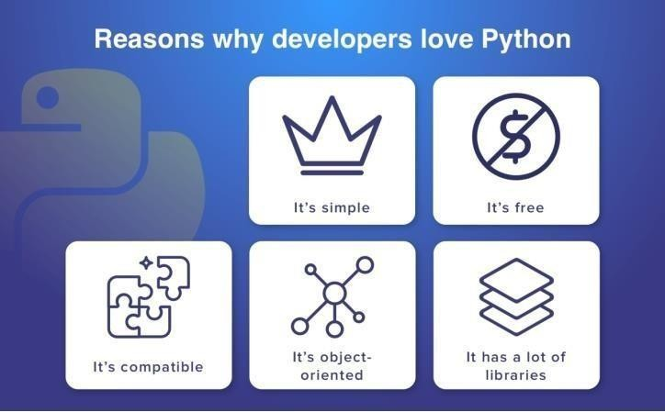**Features of Python Programming**

**1.** A simple language which is easier to learn

* + Python has a very simple and elegant syntax.
  + It's much easier to read and write Python programs compared to other languages like: C++, Java, C#.
  + Python makes programming fun and allows you to focus on the solution rather than syntax.
  + If you are a newbie, it's a great choice to start your journey with Python.

**2.**Free and open-source

* + You can freely use and distribute Python, even for commercial use.
  + Not only you can use and distribute software’s written in it, you can even make changes to the Python's source code.
  + Python has a large community constantly improving it in eachiteration.

1. Portability

* It runs seamlessly on almost all platforms including Windows, Mac OS and Linux.

1. Extensible and Embeddable

* Suppose an application requires high performance. You can easily combine pieces of C/C++ or other languages with Python code.
  + This will give your application high performance as well as scripting capabilities which other languages may not provide out of the box.

1. A high-level, interpreted language

* Unlike C/C++, you don't have to worry about daunting tasks like memory management, garbage collection and so on.
  + Likewise, when you run Python code, it automatically converts your code to the language your computer understands. You don't need to worry about any lower-level operations.

1. Large standard libraries to solve common tasks
   * Python has several standard libraries which makes life of a programmer much easier since you don't have to write all the code yourself.
   * For example: Need to connect MySQL database on a Web server? You can use MySQL dB library using import MySQL db.
   * Standard libraries in Python are well tested and used by hundreds of people. So, you can be sure that it won't break your application.

**1.Object-oriented**

* + Everything in Python is an object. Object oriented programming (OOP) helps you solve a complex problem intuitively.
  + With OOP, you can divide these complex problems into smaller sets by creating objects.

**Reasons to Choose Python as First Language**

**1.Simple Elegant Syntax**

* + Programming in Python is fun. It's easier to understand and write Python code. Why? The syntax feels natural. Take this source code for an example:

a = 2

b = 3

sum = a + b print(sum)

* Even if you have never programmed before, you can easily guess that this program adds two numbers and prints it.

1. **Not overly strict**
   * You don't need to define the type of a variable in Python. Also, it's not necessary to add semicolon at the end of the statement.
   * Python enforces you to follow good practices (like proper indentation). These small things can make learning much easier for beginners.

**1.Expressiveness of the language**

* + Python allows you to write programs having greater functionality with fewer lines of code. Here's a link to the source code of Tic-tac-toe game with a graphical interface and a smart computer opponent in less than 500 lines of code. This is just an example. You will be amazed how much you can do with Python once you learn the basics.

**2.Great Community and Support**

* + Python has a large supporting community. There are numerous active forums online which can be handy if you are stuck. Some of them are:
  + Google Forum for Python
  + Python Questions - Stack Overflow

**Python vs PHP**

From the development point of view, PHP is a web-oriented language.

Choosing between **Python or PHP for web applications** pay attention to these characteristics:

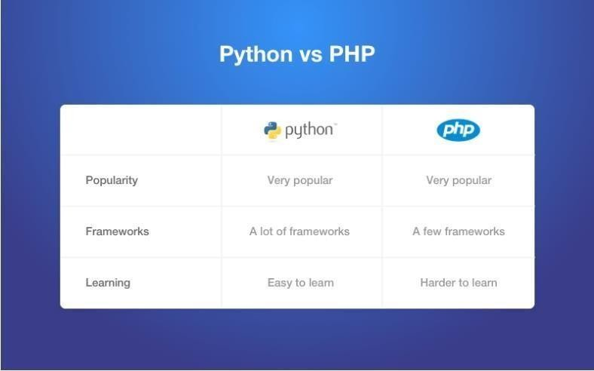

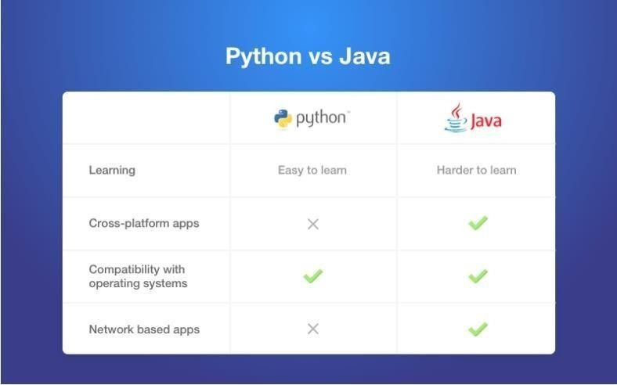

**Python vs C#**

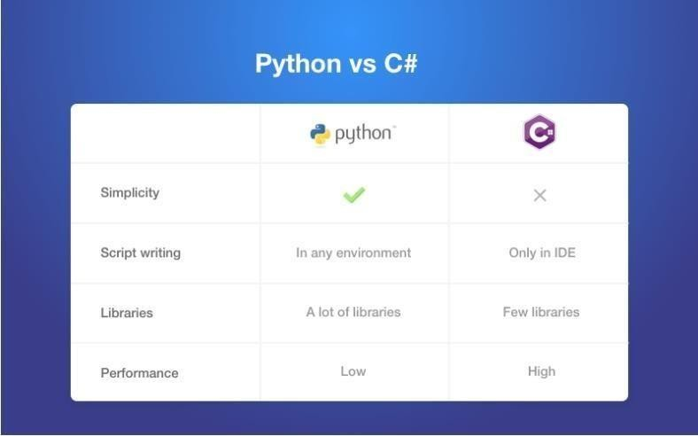

**Difference between Ruby and Python**

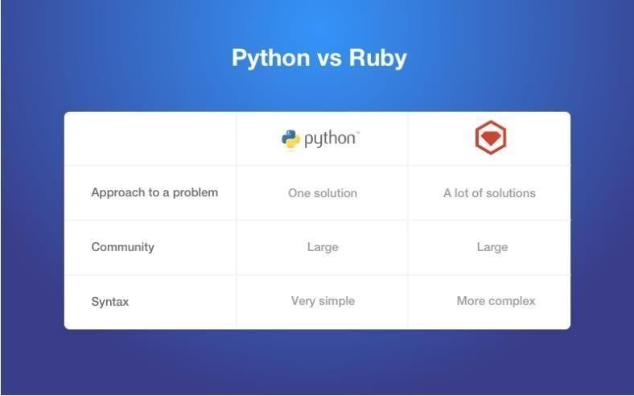In terms of the first language, Ruby and Python are the most popular ones. Ruby is extremely popular technology for building websites. Among the most famous are Twitter (the early version), Basecamp, Github, Airbnb, Slideshare and Groupon**.**

**Installing and Running Python in Windows**

Go to Download Python page on the official site and click Download Python 3.7 (You may see different version name).

When the download is completed, double-click the file and follow the instructions to install it.

When Python is installed, a program called IDLE is also installed along with it. Itprovides graphical user interface to work with Python.

Open IDLE, copy the following code below and press enter. print("Hello, World!")

To create a file in IDLE, go to File > New Window (Shortcut: Ctrl+N).

Write Python code (you can copy the code below for now) and save (Shortcut: **Ctrl+S**) with

**.py** file extension like: hello.py or your-first-program.py print("Hello, World!")

Go to **Run > Run module** (Shortcut: **F5**) and you can see the output. Congratulations, you've

successfully run your first Python program.

**PYTHON HAS TWO BASIC MODES:**

**Interactive mode:** is a command line shell which gives immediate output for each statement, while running previously statements in **active** memory.

This mode is also referred as REPL (Read Evaluate Print Loop)

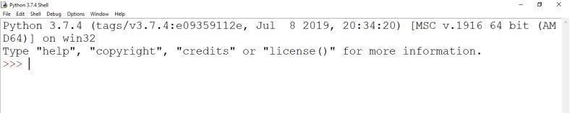

**We can start an interactive session from Command Prompt Directly.**

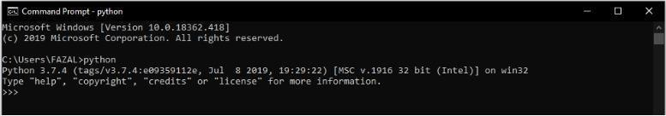

**Normal mode:**

is where the scripted python file (.py) run in the Python interpreter.

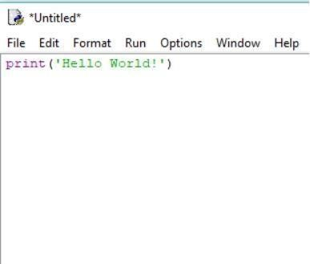

**PYTHON PROGRAM TO ADD TWO NUMBERS**

# This program adds two numbers num1 = 1.5

num2 = 6.3

# Add two numbers

sum = float(num1) + float(num2) # Display the sum

print('The sum of {0} and {1} is {2}'.format(num1, num2, sum))

**ADD TWO NUMBERS PROVIDED BY THE USER**

# Store input numbers

num1 = input('Enter first number: ') num2 = input('Enter second number: ')

# Add two numbers

sum = float(num1) + float(num2)

# Display the sum

print('The sum of {0} and {1} is {2}'.format(num1, num2, sum))

We use the built-in function input() to take the input.

input() returns a string, so we convert it into number using the float() function.

**Python Quick start**

Python is an interpreted programming language, this means that as a developer you write Python (.py) files in a text editor and then put those files into the python interpreter to be executed.

The way to run a python file is like this on the command line:

C:\Users*Your Name*>python helloworld.py

Where "helloworld.py" is the name of your python file.

Let's write our first Python file, called helloworld.py, which can be done in any text editor. helloworld.py

print("Hello, World!")

Simple as that. Save your file. Open your command line, navigate to the directory where you saved your file, and run:

C:\Users*Your Name*>python helloworld.py The output should read:

Hello, World!

Congratulations, you have written and executed your first Python program.

**The Python Command Line**

To test a short amount of code in python sometimes it is quickest and easiest not to write the code in a file. This is made possible because Python can be run as a command line itself.

Type the following on the Windows, Mac or Linux command line: C:\Users*Your Name*>python From there you can write any python, including our hello world example from earlier in the tutorial:

C:\Users*YourName*>python

Python 3.6.4 (v3.6.4:d48eceb, Dec 19 2017, 06:04:45) [MSC v.1900 32 bit (Intel)] onwin 32 Type "help", "copyright", "credits" or "license" for more information.

>>> print("Hello, World!")

Which will write "Hello, World!" in the command line:

Whenever you are done in the python command line, you can simply type the following to quit the python command line interface:

exit()

**Python - GUI Programming (Tkinter)**

Python provides various options for developing graphical user interfaces (GUIs). Mostimportant are listed below.

* **Tkinter** − Tkinter is the Python interface to the Tk GUI toolkit installed with Python.
* **wxPython** − This is an open-source Python interface for wxWindows
* **JPython** − JPython is a Python port for Java which gives Python scripts seamless access to Java class libraries on the local machine

**Tkinter Programming**

Tkinter is the standard GUI library for Python.

Python when combined with Tkinter provides a fast and easy way to create GUI applications. Tkinter provides a powerful object-oriented interface to the Tk GUI toolkit.

Creating a GUI application using Tkinter, we need to do is perform the following steps

Import the *tkinter* module.

* Create the GUI application main window
* Add one or more widgets to the GUI application.
* Enter the main event loop to take action against each event triggered by the user.

**Tkinter Widgets**

tkinter provides various controls, such as buttons, labels and text boxes used in a GUI

|  |  |
| --- | --- |
| **Sr.No.** | **Operator & Description** |
| **1** | Button  The Button widget is used to perform some action when clicked. |
| **2** | Canvas  The Canvas widget is used to draw shapes, such as lines, ovals, polygons and rectangles, in your application. |
| **3** | Checkbutton  The Checkbutton widget is used to display a number of options as checkboxes. The user can select multiple options at a time. |
| **4** | Entry  The Entry widget is used to display a single-line text field for accepting values from a user. |
| **5** | Frame  The Frame widget is used as a container widget to organize other widgets. |
| **6** | Label  The Label widget is used to provide a single-line caption for other widgets. It can also contain images. |
| **7** | Listbox  The Listbox widget is used to provide a list of options to a user. |
| **7** | Listbox  The Listbox widget is used to provide a list of options to a user. |

|  |  |
| --- | --- |
| **8** | Menubutton  The Menubutton widget is used to display menus in your application. |
| **9** | Menu  The Menu widget is used to provide various commands to a user. These commands are contained inside Menubutton. |
| **10** | Message  The Message widget is used to display multiline text fields for accepting values from a user. |
| **11** | Radiobutton  The Radiobutton widget is used to display several options as radio buttons. The user can select only one option at a time. |
| **12** | Scale  The Scale widget is used to provide a slider widget. |
| **13** | Scrollbar  The Scrollbar widget is used to add scrolling capability to various widgets, such as list boxes. |
| **14** | Text  The Text widget is used to display text in multiple lines. |
| **15** | Toplevel  The Toplevel widget is used to provide a separate window container. |
| **16** | Spinbox |

The Spinbox widget is a variant of the standard Tkinter Entry widget, which can be used to select from a fixed number of values.

Let us study these widgets in detail −

Standard attributes

Let us look at how some of their common attributes. such as sizes, colors and fonts are specified.

* Dimensions
* Colors
* Fonts
* Anchors
* Relief styles
* Bitmaps
* Cursors

Geometry Management

All Tkinter widgets have access to specific geometry management methods, which have the purpose of organizing widgets throughout the parent widget area.

Tkinter contains the following geometry manager classes: pack, grid, and place.

* The *pack()* Method − organizes widgets in blocks before placing them in the parent widget.
* The *grid()* Method − organizes widgets in a table-like structure in the parent widget.
* The *place()* Method − organizes widgets by placing them in a specific position .

**Why Django?**

Django is a Web framework written in Python.

A Web framework is a software that supports the development of dynamic Web sites, applications, and services.

It provides a set of tools and functionalities that solves many common problems associated with Web development, such as security features, database access, sessions, template processing, URL routing, internationalization, localization, and much more.

Using a Web framework, such as Django, enables us to develop secure and reliable Web applications very quickly in a standardized way.

The development of Django is supported by the [Django Software Foundation,](https://www.djangoproject.com/foundation/) and it’s sponsored by companies like JetBrains and Instagram.

Who’s Using Django?

It’s good to know who is using Django out there, so to have an idea what you can do with it. Among the biggest Web sites using Django we have: [Instagram, Disqus,](https://instagram.com/) [Mozilla, Bitbucket](https://www.mozilla.org/), [Last.fm, National Geographic](https://www.last.fm/)

**Installation**

The first thing we need to do is install some programs on our machine so to be able to start playing with Django. The basic setup consists of installing

* **Python**
* **Virtualenv**
* **Django**

we are going to use **pip**, a tool to manage and install Python packages, to install **virtualenv**. In the Command Prompt, execute the command below: pip install virtualenv.

From now on, everything we install, including Django itself, will be installed inside a Virtual Environment.

mkdir myproject

cd myproject

This folder is the higher level directory that will store all the files and things related to our Django project, including its virtual environment.

let’s start by creating our very first virtual environment and installing Django. Inside the **myproj** folder:**virtualenv myvenv**

Our virtual environment is created.

Now before we start using it, we need to activate:

myvenv\Scripts\activate

You will know it worked if you see (venv) in front of the command line, like this:

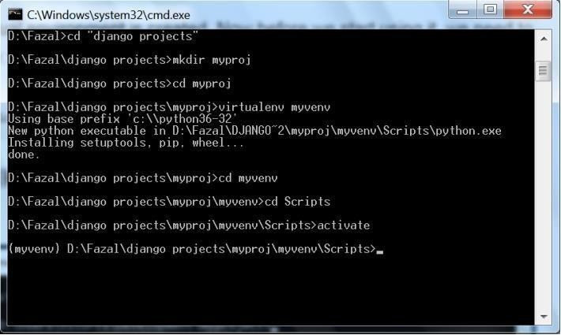

to deactivate the **venv** run the command below:

venv\Scripts\deactivate.bat

But let’s keep it activated for the next steps.

Installing Django

Now that we have the **venv** activated, run the following command to install Django:

pip install django

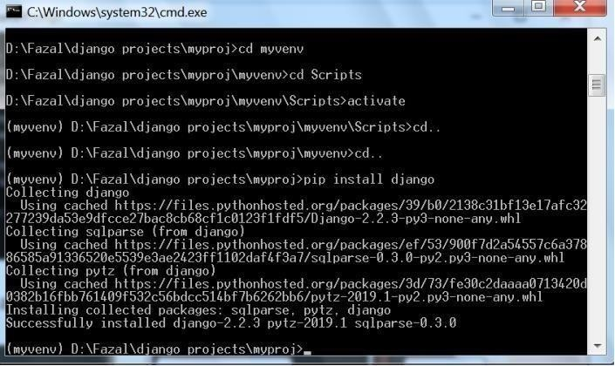

*Starting a New Project*

To start a new Django project, run the command below:

django-admin startproject myproject

The command-line utility **django-admin** is automatically installed with Django.

After we run the command above, it will generate the base folder structure for a Django project. Our initial project structure is composed of five files:

* **manage.py**: a shortcut to use the **django-admin** command-line utility. It’s used to run management commands related to our project.

We will use it to run the development server, run tests, create migrations and much more.

* **init .py**: this empty file tells Python that this folder is a Python package.
* **settings.py**: this file contains all the project’s configuration.
* **urls.py**: this file is responsible for mapping the routes and paths in our project.

For example, if you want to show something in the URL /about/, you have to map it here first.

* **wsgi.py**: this file is a simple gateway interface used for deployment.

You don’t have to bother about it. Just let it be for now.

Django comes with a simple web server installed.

It’s very convenient during the development, so we don’t have to install anything else to runthe project locally.

We can test it by executing the command:

python manage.py runserver

For now, you can ignore the migration errors; we will get to that later.

Now open the following URL in a Web browser: **http://127.0.0.1:8000** and you should see the

Hit CTRL + BREAK to stop the development server.

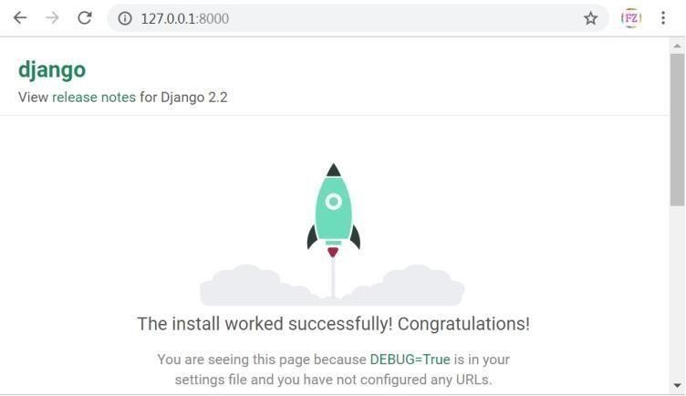

r fir*Django Apps*

In the Django philosophy we have two important concepts:

* **app**: is a Web application that does something.

An app usually is composed ofa set of models (database tables), views, templates, tests.

* **project**: is a collection of configurations and apps.

One project can be composed of multiple apps, or a single app.

It’s important to note that you can’t run a Django **app** without a **project**. Simple websites like a blog can be written entirely inside a single app, which could be named **blog** or **weblog** for example.

let’s create a simple Web Forum or Discussion Board. To create oust app, go to the directory where the **manage.py** file is and executes the following command:

django-admin startapp boards

Notice that we used the command **startapp** this time.

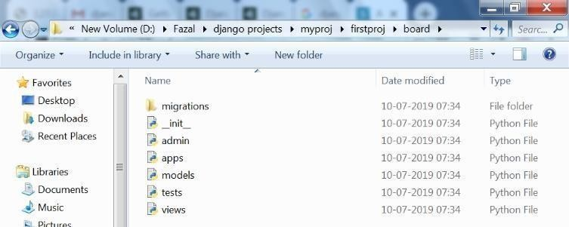

So, let’s first explore what each file does:

* **migrations/**: here Django store some files to keep track of the changes you create in the **models.py** file, so to keep the database and the **models.py** synchronized.
* **admin.py**: this is a configuration file for a built-in Django app called **Django Admin**.
* **apps.py**: this is a configuration file of the app itself.
* **models.py**: here is where we define the entities of our Web application. The models are translated automatically by Django into database tables.
* **tests.py**: this file is used to write unit tests for the app.
* **views.py**: this is the file where we handle the request/response cycle of our Web application.
* Now that we created our first app, let’s configure our project to *use* it.
* To do that, open the **settings.py** and try to find the INSTALLED_APPS variable:

### settings.py

* INSTALLED_APPS **=** [
* 'django.contrib.admin',
* 'django.contrib.auth',
* 'django.contrib.contenttypes',
* 'django.contrib.sessions',
* 'django.contrib.messages',
* 'django.contrib.staticfiles',]

O As you can see, Django already come with 6 built-in apps installed. They offer common functionalities that most Web applications need, like authentication, sessions, static files management (images, javascripts, css, etc.) and so on.

* *Hello, World!*
* Let’s write our first **view**. We will explore it in great detail in the next tutorial. But for now, let’s just experiment how it looks like to create a new page with Django.
* Open the **views.py** file inside the **boards** app, and add the following code:

### views.py

o from django.http import HttpResponse **def home**(request):

Views are Python functions that receive an HttpRequest object and returns an HttpResponse object. Receive a *request* as a parameter and returns a *response* as a result. That’s the flow you have to keep in mind!

So, here we defined a simple view called **home** which simply returns a message saying **Hello, World!**.

Now we have to tell Django *when* to serve this view. It’s done inside the **urls.py** file:

### urls.py

from django.conf.urls import url from django.contrib import admin

from boards import views

urlpatterns = [

url(r'^$', views.home, name='home'),

url(r'^admin/', admin.site.urls),

]

If you compare the snippet above with your **urls.py** file, you will notice I added the following new line: url(r'^$', views.home, name='home') and imported the **views** module from our app **boards** using from boards import views.

As I mentioned before, we will explore those concepts in great detail later on.

But for now, Django works with **regex** to match the requested URL. For our **home** view, I’m using the ^$ regex, which will match an empty path, which is the homepage (this url: **http://127.0.0.1:8000**). If I wanted to match the URL **http://127.0.0.1:8000/homepage/**, my url would be:

url(r'^homepage/$', views.home, name='home').

Let’s see what happen:

python manage.py runserve In a Web browser, open the http://127.0.0.1:8000 URL:

**SCREENSHOTS**

**5.3**

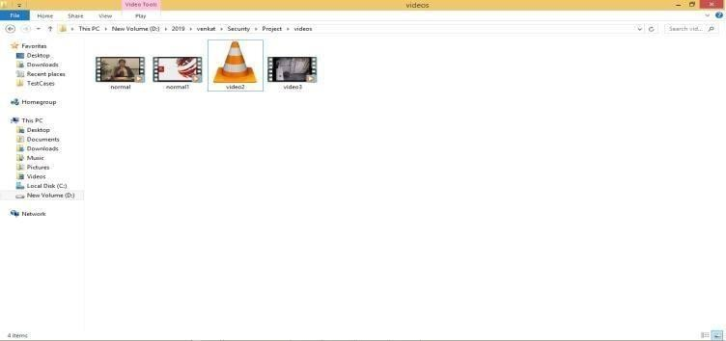

Double click on ‘run.bat’ file from project folder to start project execution. We will get below screen

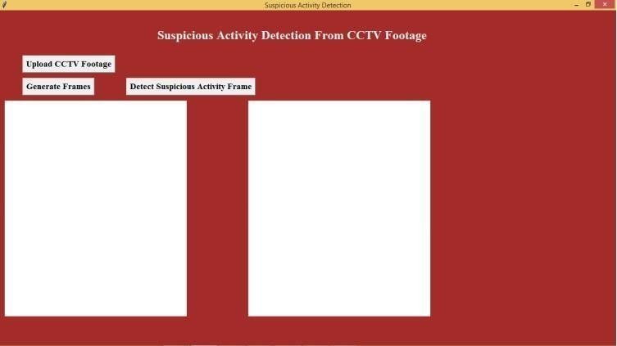

Click on ‘Upload CCTV Footage’ button to upload video

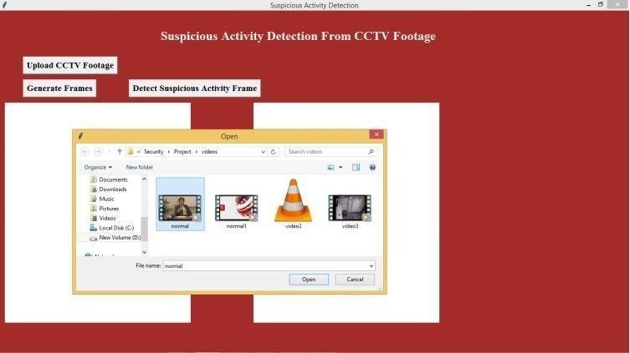

In above screen i am uploading one normal video. After uploading video click on ‘Generate Frames’ button to generate frame.

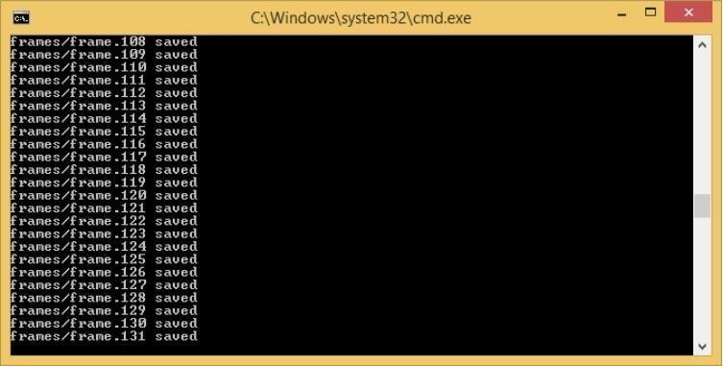

In above black screen we can see extracted frames are saving inside ‘frames’ folder frame no. Now we see frames folder below which has images from video.



In above folder screen we can see all images from video extracted. After frame extraction will get below screen..

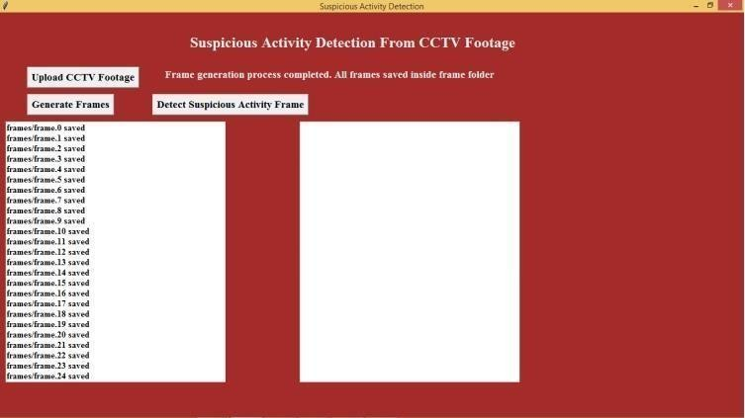

Now click on ‘Detect Suspicious Activity Frame’ button to start monitoring frames for suspicious activity.

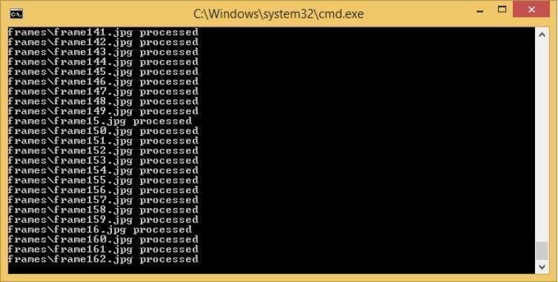

In above black console window we can see processing of each frame to detect suspicious activity.

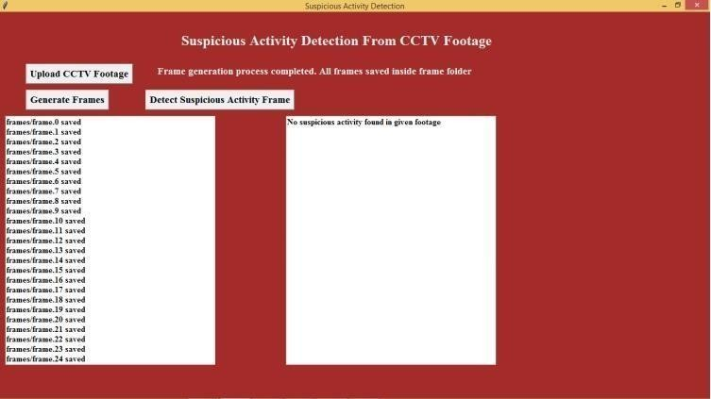

In above screen we can see frames scanned and no suspicious activity found. Now we will upload another video and check status.

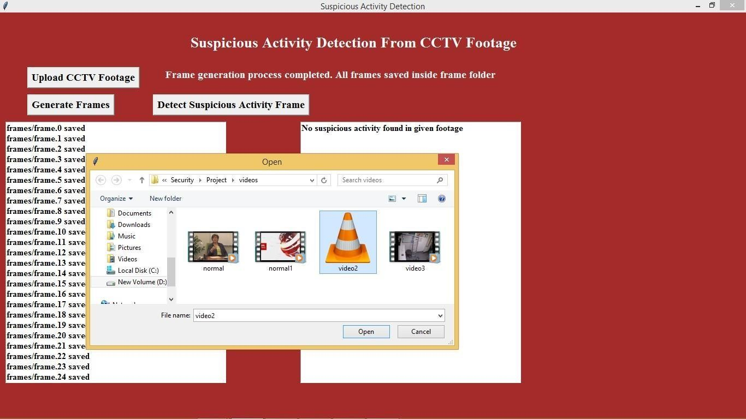

In above screen i am uploading ‘Video2’ and then extract frames.

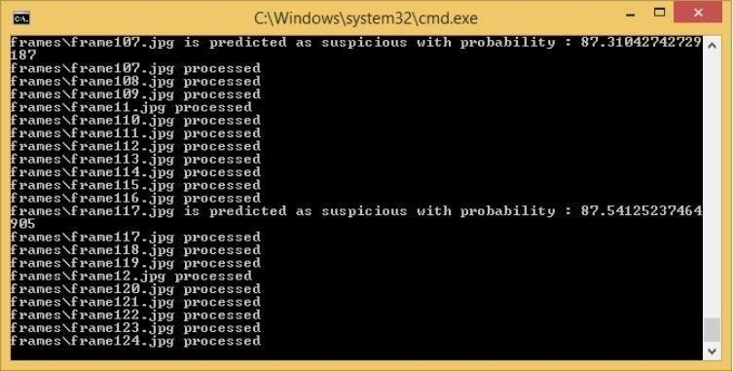

In above screen for uploaded video we can see suspicious activity found at farme117.jpg. After scanning all images we will get below details screen. Now in below screen we can see frame117.jpg image from frames folder.

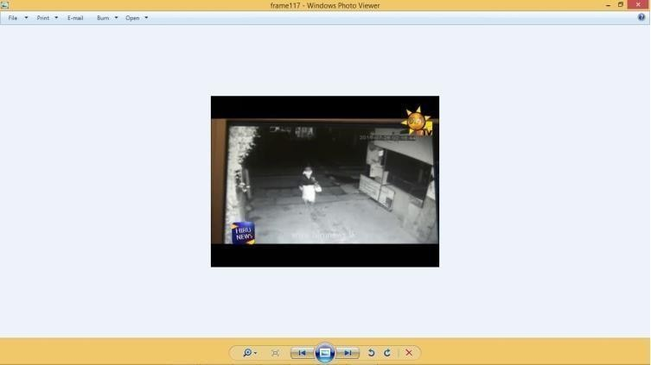

In above screen frame117 showing one image of a person with face covering. Similarly we can see all frames details in below screen which has such activities.

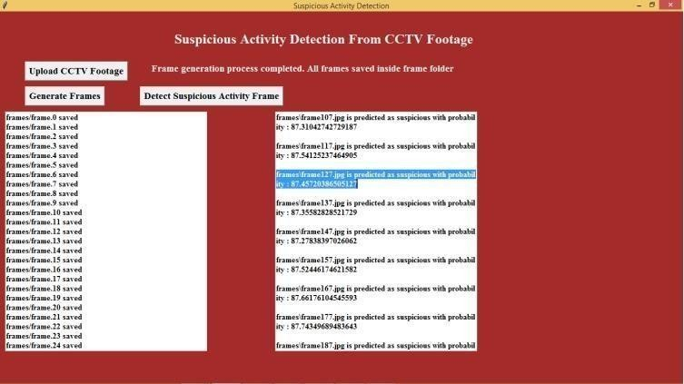

In above screen in right text area we can see details of all frames which has such activities.

Note: you to can upload your own videos and check but your videos must have person covering their faces or doing shop lifting robbers videos. Your videos must be like similar one which i used in this project.

**SYSTEM TESTING**

**6.SYSTEM TESTING**

The purpose of testing is to discover errors. Testing is the process of trying to discover every conceivable fault or weakness in a work product. It provides a way to check the functionality of components, sub assemblies, assemblies and/or a finished product It is the process of exercising software with the intent of ensuring that the Software system meets its requirements and user expectations and does not fail in an unacceptable manner. There are various types of test. Each test type addresses a specific testing requirement.

### TYPES OF TESTS:

**6.1 Unit testing:**

Unit testing involves the design of test cases that validate that the internal program logic is functioning properly, and that program inputs produce valid outputs. All decision branches and internal code flow should be validated. It is the testing of individual software units of the application .it is done after the completion of an individual unit before integration. This is a structural testing, that relies on knowledge of its construction and is invasive. Unit tests perform basic tests at component level and test a specific business process, application, and/or system configuration. Unit tests ensure that each unique path of a business process performs accurately to the documented specifications and contains clearly defined inputs and expected results.

**6.2 Integration testing**

Integration tests are designed to test integrated software components to determine if individually satisfaction, as shown by successfully unit testing, the combination of components is correct and consistent. Integration testing is specifically aimed at exposing the problems that arise from the combination of components.

**6.3 Functional testing**

Functional tests provide systematic demonstrations that functions tested are available as specified by the business and technical requirements, system documentation, and user manuals.

Functional testing is centered on the following items:

Valid Input : identified classes of valid input must be accepted.

Invalid Input : identified classes of invalid input must be rejected.

Functions : identified functions must be exercised.

Output : identified classes of application outputs must be exercised. Systems/Procedures: interfacing systems or procedures must be invoked.

Organization and preparation of functional tests is focused on requirements, key functions, or special test cases. In addition, systematic coverage pertaining to identify Business process flows; data fields, predefined processes, and successive processes must be considered for testing. Before functional testing is complete, additional tests are identified and the effective value of current tests is determined.

**System Test**

System testing ensures that the entire integrated software system meets requirements. It tests a configuration to ensure known and predictable results. An example of system testing is the configuration oriented system integration test. System testing is based on process descriptions and flows, emphasizing pre-driven process links and integration points

**White Box Testing**

White Box Testing is a testing in which in which the software tester has knowledge of the inner workings, structure and language of the software, or at least its purpose. It is purpose. It is used to test areas that cannot be reached from a black box level.

**Black Box Testing**

Black Box Testing is testing the software without any knowledge of the inner workings, structure or language of the module being tested. Black box tests, as most other kinds of tests, must be written from a definitive source document, such as specification or requirements document, such as specification or requirements document. It is a testing in which the software under test is treated, as a black box .you cannot “see” into it. The test provides inputs and responds to outputs without considering how the software works.

**Test strategy and approach**

Field testing will be performed manually and functional tests will be written in detail.

**Test objectives**

* All field entries must work properly.
* Pages must be activated from the identified link.

System testing ensures that the entire integrated software system meets requirements. It tests a configuration to ensure known and predictable results. An example of system testing is the configuration oriented system integration test. System testing is based on process descriptions and flows, emphasizing pre-driven process links and integration points.

**Features to be tested**

* Verify that the entries are of the correct format
* No duplicate entries should be allowed
* All links should take the user to the correct page.

**Integration Testing**

Software integration testing is the incremental integration testing of two or more integrated software components on a single platform to produce failures caused by interface defects.

The task of the integration test is to check that components or software applications, e.g. components in a software system or – one step up – software applications at the company level

– interact without error.

**Test Results:**

All the test cases mentioned above passed successfully. No defects encountered.

**Acceptance Testing**

User Acceptance Testing is a critical phase of any project and requires significant participation by the end user. It also ensures that the system meets the functional requirements.

**Test Results:**

All the test cases mentioned above passed successfully. No defects encountered.

**CONCLUSION AND FUTURE ENHANCEMENT**

### 7.CONCLUSION

### 7.1 CONCLUSION:

In this work, a semantics-based activity detection approach that depends on object tracking is used. It uses the motion features and spatial relation between two objects. The features are continuously checked against predefined conditions, to detect the prescribed activities of interest. The approach is simple for real-time performance, and it eliminates the training required by machine-learning-based methods.

**7.2 FUTURE ENHANCEMENT:**

* Shoplifting, Robbery and Break-In images are down-loaded from Google hence they are heterogeneous. The images might contain noise, some of the images might be blur, also they may be of low resolution. Hence to improve the performance of the model we need to train CNN with proper images.
* Therefore, the future scope ofthe project is to have a high quality dataset which contains real life Shoplifting, Robbery and Break-In images . Also ﬂickering effect is seen in the output video, which can be further minimized by making a proper selection of a subset of frames from the queue

**REFERENCES**

**8.REFERENCES**

* 1. Sandesh Patil and Kiran Talele “Suspicious Movement Detection and Tracking based on Color Histogram”, 2015 International Conference on Communication, Information & Computing Technology (ICCICT), Jan. 16-17.
  2. Mohannad Elhamod, and Martin D. Levine, “Automated Real-Time Detection of Potentially Suspicious Behavior in Public Transport Areas”,IEEE Transactions On Intelligent Transportation Systems, Vol. 14, No.2, June 2013.
  3. Evangelio, R., Sikora, T., “Static object detection based on a dual background model and a finite-state machine”. EURASIP Journal on Image and Video Processing 2011.
  4. Birch, P., Hassan, W., Bangalore, N., Young, R., Chatwin, C., “Stationary traffic monitor”. In Proc. 4th Internat. Conf. on Imaging for Crime Detection and Prevention (ICDP- 11), pp. 1–6, 2011.
  5. Tian, Y., Feris, R., Liu, H., Humpapur, A., Sun, M.-T., “Robust detection of abandoned and removed objects in complex surveillance videos”. In Proc. IEEE 2010.
  6. Porikli, F., Ivanov, Y., Haga, T., 2008. “Robust abandoned object detection using dual foregrounds” EURASIP Journal on Advances in Signal Processing 2008.
  7. James Ferryman et al, “Robust abandoned object detection integrating wide area visual surveillance and social context” in Pattern Recognition Letters 34 (2013) 789–798 Elsevier

[8] 2013.

**9.BIBLIOGRAPY** W3SCHOOLS GREEKS OF GREEKS PYTHON.ORG